Mastering Embedded System Online Diploma

www.learn-in-depth.com

First Term (Final Project 1)

Eng. Mina Fathy Labib Hakim

My Profile:

# Specification from Client:

* A pressure controller informs the crew of a cabin with an alarm when the pressure exceeds 20 bars in the cabin.
* The alarm duration equals 60 seconds.

# Requirements Diagram:

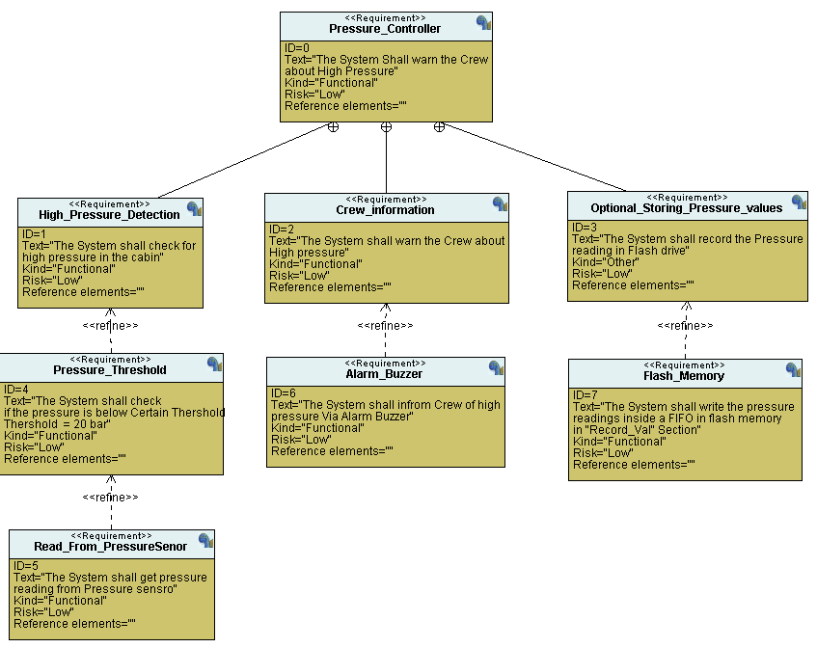

# Space exploration/Partitioning:

**The project is quiet simple it doesn’t require more than one ECU and STM32 was found suitable for this project.**

# System Analysis:

## Use Case Diagram:

## Activity Diagram:

## Sequence Diagram:

# System Design:

## Block Diagram:

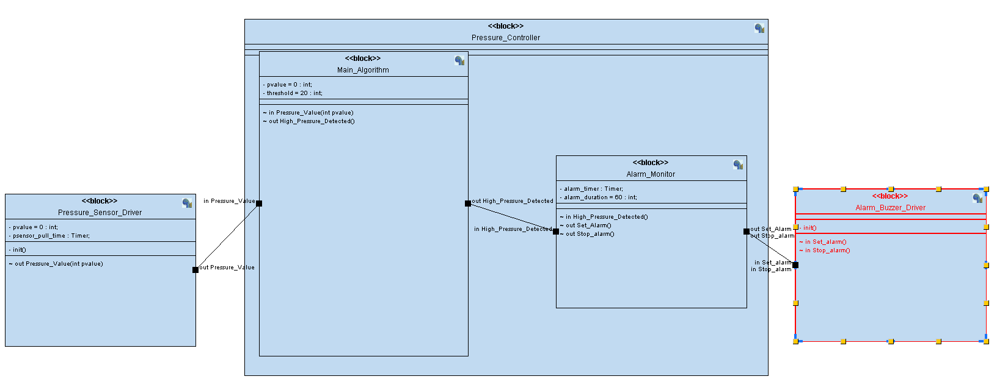

## Pressure Sensor Driver Logic:

## Main Algorithm Logic:

## Alarm Monitor Logic:

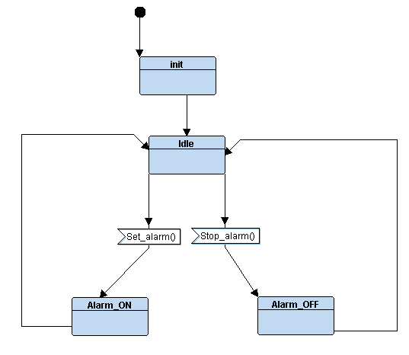

## Alarm Driver Logic:

# Simulation:

## TTool Simulation:

## Proteus Simulations:

* 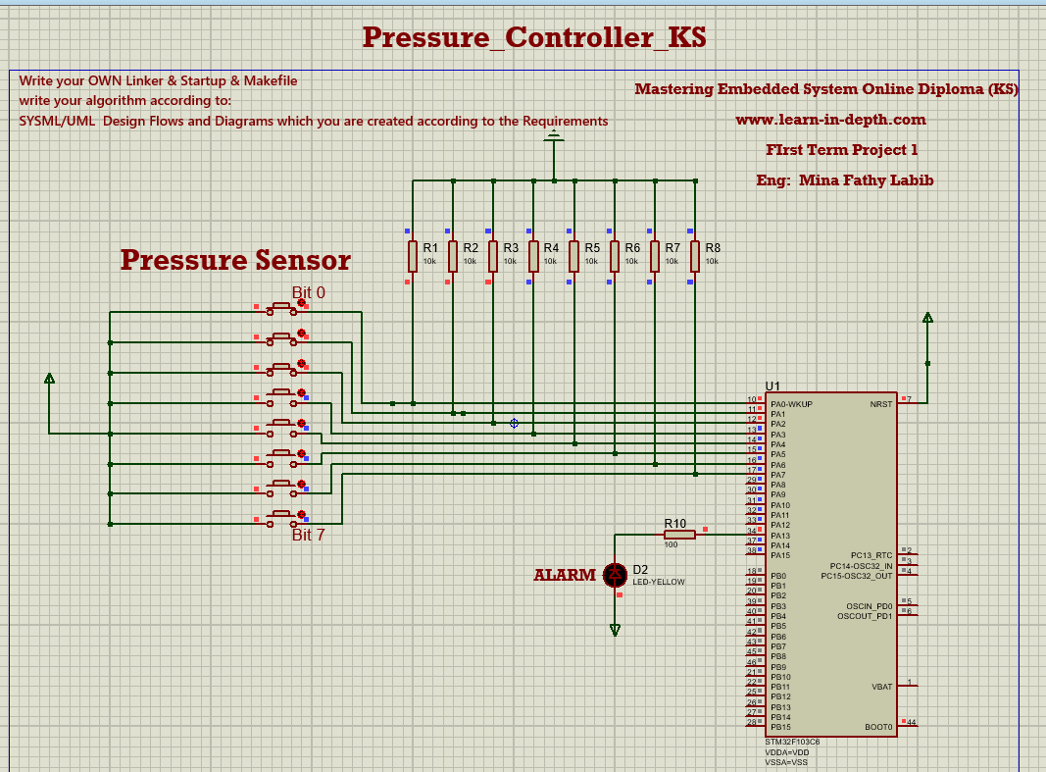Alarm OFF (Pressure = 7 bar)
* 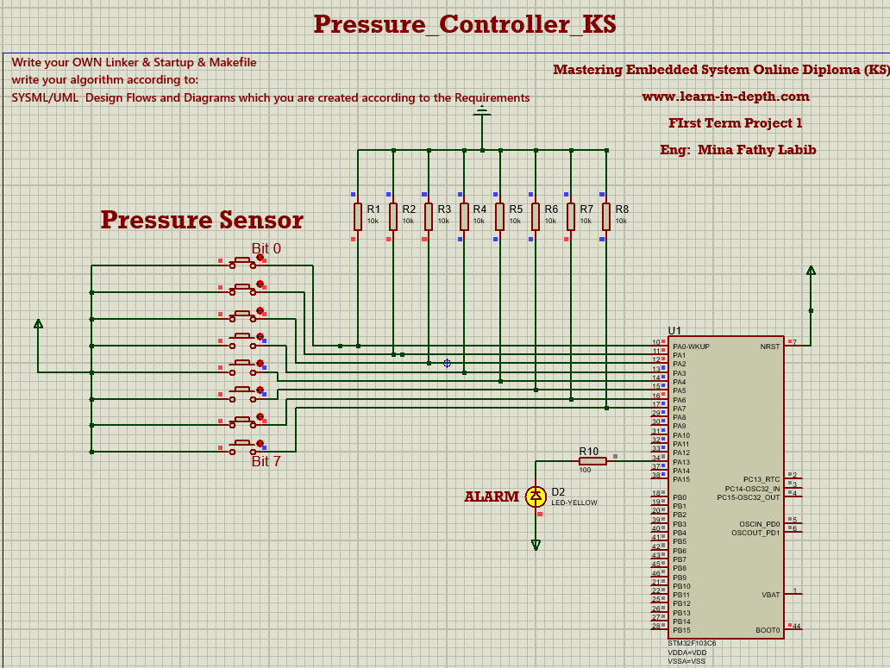A

## Executable Symbol Table:

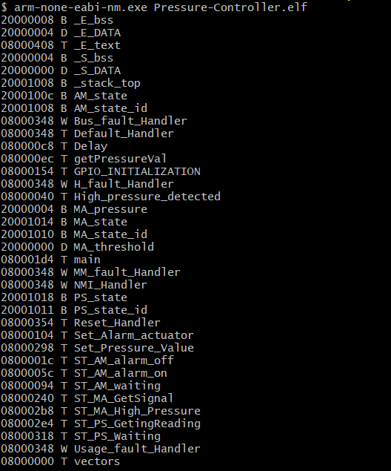

* larm ON (Pressure = 71 bar > 20 bar)